**Problem Statement**

**Product Dissection for top leading Platforms**

Welcome to this case study on dissecting and designing products for top leading platforms. In this case study, you will delve into the intriguing world of schema design for a prominent platform of your choice. Your task is to choose a top leading platform, research its features, and meticulously craft a schema design that encapsulates the essence of its functionality. By focusing on key entities, attributes, and relationships, you will gain invaluable insights into how data architecture drives the platform's effectiveness.

**Step 1: Choose a Leading Platform**

Select a leading platform of your choice, which could span various domains such as social media, e-commerce, finance, or any other industry. This choice will form the foundation of your exploration into its schema design.

**Step 2: Research:**

Thoroughly research the platform you have selected. Investigate its core features, functionalities, and user interactions. Identify the top features that define its user experience and contribute significantly to its popularity.

**Step 3: Product Dissection and Real-World Problems solved by the platform**

In this step, you will meticulously analyse the platform's standout features and how they provide innovative solutions to real-world challenges. By identifying key functionalities that resonate with users, you'll unravel how the platform effectively addresses problems and enhances user experiences. This dissection will serve as the foundation for understanding how the schema design aligns with the platform's core objectives.

**Step 4: Case Study on the real-world problems and approach to solving them**

In this pivotal step, you will expand on the real-world challenges uncovered in Step 3 through a comprehensive case study. Delve into specific instances where users encountered difficulties and showcase how the platform's unique features provided effective solutions. By dissecting the approach taken by the platform to overcome these challenges, you'll gain a deeper appreciation for the platform's user-centric design philosophy and how it shapes the schema design.

**Step 5: Schema Design Based on Top Features**

Based on the features you have identified, craft a schema design that reflects the platform's data structure. Focus on the key entities, attributes, and relationships that underpin the chosen features. Your schema should capture the essence of how the platform organises and utilises its data.

**Step 6: Rationale Behind the Design**

While creating the schema design, consider the rationale behind the platform's choices. Reflect on why certain entities and relationships were chosen and how they align with the platform's goals. This will help you understand the strategic decisions driving the schema's architecture.

**Step 7: Create an ER Diagram**

Utilise tools like the Miro platform or similar applications to create an illustrative Entity-Relationship (ER) diagram. This diagram should vividly depict the entities, attributes, and relationships present within your schema design. The ER diagram will serve as a visual representation of your insights.

**Step 8: Presentation of Findings**

Present your findings in a clear and concise manner. Showcase your understanding of how the schema design impacts the platform's functionality and user experience. Explain how your chosen features are integrated into the schema and how the schema's structure supports the platform's objectives.

**Task Details:**

1. **Answer Submission:** Your submission should include well-structured solutions for all provided questions related to product schema designs.
2. **Video Creation:** Create an informative and engaging video where you thoroughly explain the Case Study.
3. **Depth and Clarity:** Ensure your solutions are detailed and showcase your understanding of product schema design principles. Similarly, in the video, provide clear explanations that are easy to understand for a wide audience.
4. **Creativity Encouraged:** You are welcome to utilise visuals, diagrams, or creative elements to enhance the clarity and impact of your explanations.

**Note:**

1. Duplicate this document and proceed to write your solutions and prepare your video.
2. Include the video link in this document before final submission.

Best of luck in completing this project and showcasing your prowess in dissecting and designing product schema for leading platforms! **For reference, we have also conducted a case study on Instagram, which you can find below. This case study will provide you with valuable insights into how schema design plays a pivotal role in shaping the functionality and success of a prominent platform.**



**Product Dissection for Swiggy**

### **Company Overview:**

Swiggy, founded in 2014, is one of India's leading online food delivery platforms. Swiggy is headquartered in Bangalore and operates in more than 580 Indian cities. It connects users with a variety of restaurants and food outlets in their locality, offering a convenient and efficient way to order food. With its user-friendly interface and vast network of delivery partners, Swiggy has become a household name in the online food delivery industry in India.

Besides food delivery, the platform also provides on-demand grocery deliveries under the name Instamart, and a same-day package delivery service called Swiggy Genie. The business model of Swiggy is based on a hyper-local on-demand food delivery business model. It makes use of modern technology and techniques to satisfy the growing demand for foodies in the market.

### **Product Dissection and Real-World Problems Solved by Swiggy:**

Swiggy addresses several real-world challenges through its innovative features and services:

**Convenience in Ordering Food**:

Swiggy offers a seamless platform for users to order food from a wide range of restaurants, providing convenience at their fingertips. Users can browse menus, place orders, and track deliveries in real-time, saving time and effort.

**Wide Range of Food Options**:

By partnering with a vast array of restaurants, Swiggy brings a wide variety of cuisines and food options to users, enhancing their dining experience.

**Reliable Delivery Service**:

Swiggy has built a robust logistics network with trained delivery personnel, ensuring timely and efficient delivery of orders, maintaining food quality and customer satisfaction.

**Promotions and Discounts**:

Swiggy offers regular discounts, promotions, and loyalty programs, making food ordering more affordable and encouraging repeat usage.

**Efficient Delivery System**:

It solves the problem of time-consuming and often inconvenient process of going out to eat or pick up food, especially in busy urban areas.

### **Case Study: Real-World Problems and Swiggy's Innovative Solutions**

#### **Problem 1: Lack of Time for Meal preparation**

**Real-World Challenge:** Individuals with hectic schedules often lack the time to prepare meals.

**Swiggy's Solution:**

Swiggy provides a platform where users can quickly order food from nearby restaurants. The app’s user-friendly interface allows for quick searches and order placements, reducing the time spent on meal preparation.

#### **Problem 2: Limited access to diverse cuisines**

**Real-World Challenge:** Smaller towns and cities often have limited dining options.

**Swiggy's Solution:**

Swiggy partners with a wide range of restaurants, offering diverse cuisines to users regardless of their location. This expands the culinary options available to users, providing access to a variety of foods.

#### **Problem 3:** **Food Discovery and Decision Fatigue**

**Real-World Challenge:** With countless restaurants and cuisines available, choosing what to eat can be overwhelming. Scrolling through endless menus and reading reviews can be time-consuming and lead to decision fatigue.

**Swiggy's Solution:**

Swiggy tackles this challenge through personalized recommendations and curated content. The app uses user data and location to suggest restaurants and dishes based on preferences and dietary needs. Additionally, Swiggy offers curated lists and collections highlighting popular choices, new trends, and local favourites. This helps users discover new options and make informed decisions quickly.

#### **Problem 4: Ensuring Timely Delivery**

**Real-World Challenge:** Ensuring that food arrives hot and fresh.

**Swiggy's Solution:**

Swiggy’s efficient logistics and real-time order tracking system ensure that deliveries are timely. The platform provides updates on the status of the order, giving users confidence in the service.

#### **Conclusion:**

#### Swiggy's success lies in its ability to understand and address real-world problems faced by its users. By focusing on convenience, food discovery, transparency, and expanding its services, Swiggy has become an integral part of many Indian households. The platform's continued innovation and commitment to solving user problems are likely to solidify its position as a leading food delivery and convenience service provider in the Indian market.

### **Top Features of Swiggy:**

1. **User Profiles:** Allows users to manage their personal information, order history, and saved addresses.
2. **Restaurant Listings:** Provides detailed listings of partner restaurants, including menus, ratings, and reviews.
3. **Order Placement and Tracking**: Facilitates easy order placement and real-time tracking of deliveries.
4. **Payment Integration:** Supports multiple payment methods, including credit/debit cards, net banking, and digital wallets.
5. **Promotions and Discounts:** Offers various deals and discounts to users, enhancing the value proposition.
6. **Ratings and Reviews:** Users can rate and review restaurants and dishes, aiding in informed decision-making for others.
7. **Customer Support:** Provides 24/7 customer support to handle inquiries and resolve issues.
8. **Easy to use interface:** User-friendly app design that makes browsing and ordering food simple and efficient.

### **Schema Description:**

The schema for Swiggy involves multiple entities representing different aspects of the platform. These entities include Users, Restaurants, Orders, Items, Delivery Partners, Promotions and Payment.

**User Entity:**

Stores user profile information.

* **UserID (Primary Key)**: Unique identifier for each user.
* **Username**: The chosen username for the user's account.
* **Email**: The user's email address.
* **Full_Name**: The user's full name.
* **Address**: The user’s delivery address.
* **Phone**: The user’s phone number.
* **Registration_Date**: The date when the user joined Swiggy.
* **UsercouponID:** The user has multiple coupons offers applied for the orders.

**Restaurant Entity:**

Contains details of partner restaurants.

* **RestaurantID (Primary Key):** Unique identifier for each restaurant.
* **Name**: Name of the restaurant.
* **Location**: Address of the restaurant.
* **Cuisine**: Type of cuisine offered.
* **Rating**: Average rating of the restaurant.
* **Contact**: Contact details of the restaurant.
* **RestaurantcouponID:** The users have coupons offered by the restaurants.

**Order Entity:**

Records information about the user orders.

* **OrderID (Primary Key)**: Unique identifier for each comment.
* **RestaurantID (Foreign Key):** The restaurant from which the order was placed.
* **UserID (Foreign Key)**: The user who placed the order.
* **Order_Date**: The date when the order was placed.
* **Status**: Current status of the order (e.g.: pending, completed)

**Items Entity:**

Lists food items offered by restaurants.

* **ItemID (Primary Key):** Unique identifier for each item
* **RestaurantID (Foreign Key):** The post being liked.
* **Name:** Name of the item.
* **Description:** Description of the item.
* **Price:** Price of the item.

**Delivery Partner Entity:**

Holds the details of the delivery personnel.

* **PartnerID (Primary Key)**: A unique identifier for each follower relationship.
* **Name**: Name of the delivery partner.
* **Phone**: Contact number of the delivery partner.
* **Vehicle**: Type of vehicle used for delivery purpose.
* **OrderID (Foreign Key)**: The order for which the delivery is done.
* **UserID (Foreign Key)**: User to whom the order is delivered.

**Promotion Entity:**

Captures information about discounts and promotional offers.

* **PromotionID (Primary Key):** A unique identifier for each hashtag.
* **Description**: Details of the promotion.
* **Discount**: Discount percentage or amount.
* **Validity**: Validity period of the promotion.
* **RestaurantcouponID**: Coupon offered by the restaurant.
* **UsercouponID**: Coupons for the user.

**Payment Entity:**

Tracks payment details for the orders.

* **PaymentID (Primary Key)**: Unique identifier for each payment.
* **OrderID (Foreign Key)**: The order for which the payment is made.
* **Amount**: The amount paid.
* **Payment_Method**: The method used for the payment. (e.g., credit card, debit card, net banking, cash on delivery)
* **Payment_Date**: The date when the payment was made.

**Relationships are:**

* **Users place Orders –** Each user can place multiple orders.
* **Restaurants have Items –** Each restaurant can offer multiple items.
* **Orders contains Items –** Each order can include multiple items.
* **Delivery partners deliver Orders –** Each delivery partner can deliver multiple orders.
* **Promotions apply to Orders for users –** Each order can have multiple promotions for the users.
* **Promotions apply to Orders by restaurants --** Each order can have multiple promotions for the users by the restaurants.
* **Payments to Orders –** Each order can have different payments.

**ER Diagram:**

Let us create an Entity-Relationship (ER) diagram to clearly illustrate the connections and characteristics of the elements in the Swiggy database structure. This ER diagram will act as a visual guide, highlighting the essential parts of Swiggy's data architecture. Utilizing this diagram will help us understand the complex relationships and interactions that shape the functioning of the platform.

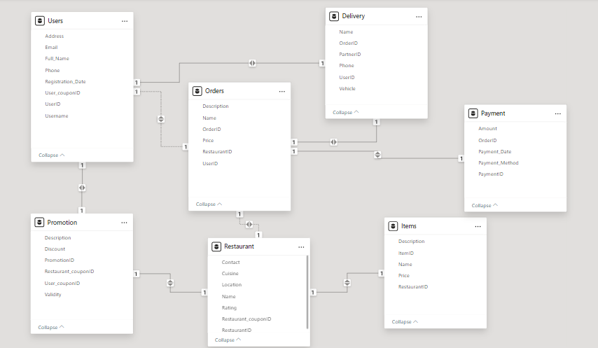

### **Conclusion**

In this case study, we delved into the design of Swiggy's schema and Entity-Relationship diagram. This product dissection of Swiggy highlights its innovative solutions to real-world problems through its user-centric features and robust platform. The schema design supports the functionality and user experience by organizing and managing data effectively, ensuring a seamless food ordering and delivery service. Swiggy’s continuous innovation and focus on user needs have positioned it as a leading player in the online food delivery industry.